* **Dharmsinh Desai University, Nadiad**

**Department of Information Technology**

**Advanced Java Technology, IT619**

**B.Tech. IT, Sem: VI**

**Experiment – 07**

**Submitted By**

**Roll No.:IT076**

**Name:Dishant Modh**

**Aim:**  Create a JSP based Web application which allows the user to edit his registration

information (Refer EXPERIMENT-4). If login is successful, the user authentication

servlet creates the welcome message for the user in session scope and then forwards the

request to JSP page which handles the edit operation. Use the JSTL core library for

variable creations, use and iterations, and JSTL SQL library for interaction with the

database.

**Code:**

**I am using experiment 4 which I have not include here.**

1. **web.xml**

<?xml version="1.0" encoding="UTF-8"?>

<web-app version="3.1" xmlns="http://xmlns.jcp.org/xml/ns/javaee" xmlns:xsi="http://www.w3.org/2001/XMLSchema-instance" xsi:schemaLocation="http://xmlns.jcp.org/xml/ns/javaee http://xmlns.jcp.org/xml/ns/javaee/web-app_3_1.xsd">

<servlet>

<servlet-name>Registration</servlet-name>

<servlet-class>Registration</servlet-class>

</servlet>

<servlet-mapping>

<servlet-name>Registration</servlet-name>

<url-pattern>/Registration</url-pattern>

</servlet-mapping>

<session-config>

<session-timeout>

30

</session-timeout>

</session-config>

</web-app>

1. **index.jsp**

<!DOCTYPE html>

<html>

<head>

<title>Exam Registration</title>

<meta http-equiv="Content-type" content="text/html; charset=UTF-8">

</head>

<body style="background-color:powderblue">

<center><h2>Registration</h2></center>

<form action="Registration">

<table>

<tr>

<td>USERID:</td>

<td><input type="text" name="uid"></td>

</tr>

<tr>

<td>PASSWORD:</td>

<td><input type="password" name="pass"></td>

</tr>

<tr>

<td>CONFORM PASSWORD:</td>

<td><input type="password" name="cpass"></td>

</tr>

<tr>

<td>FullName:</td>

<td><input type="text" name="fname"></td>

</tr>

<tr>

<td>SEMESTER:</td>

<td>

<input type="radio" name="sem" value="1"> 1

<input type="radio" name="sem" value="2"> 2

<input type="radio" name="sem" value="3"> 3

<input type="radio" name="sem" value="4"> 4

<input type="radio" name="sem" value="5"> 5

<input type="radio" name="sem" value="6"> 6

<input type="radio" name="sem" value="7"> 7

<input type="radio" name="sem" value="8"> 8<br>

</td>

</tr>

<tr>

<td>ROLLNO:</td>

<td><input type="text" name="rno"></td>

</tr>

<tr>

<td>EMAIL:</td>

<td><input type="text" name="email"></td>

</tr>

<tr>

<td>CONTACT NO:</td>

<td><input type="text" name="contact"></td>

</tr>

<tr>

<td><input type="submit" value = "REGISTER"></td>

</tr>

</table>

</form>

</body>

</html>

1. **page.jsp**

<%@ page import="java.io.*,java.util.*,java.sql.*"%>

<%@ page import="javax.servlet.http.*,javax.servlet.*" %>

<%@ taglib uri="http://java.sun.com/jsp/jstl/core" prefix="c"%>

<%@ taglib uri="http://java.sun.com/jsp/jstl/sql" prefix="sql"%>

<html>

<head>

<title>sql:update Tag</title>

</head>

<body>

<sql:setDataSource var="db" driver="org.apache.derby.jdbc.ClientDriver"

url="jdbc:derby://localhost:1527/Registration"

user="dmx" password="dmx"/>

<%-- <c:out value='${sessionScope.dmx}'/> --%>

<c:set var="Userid" value= "${sessionScope.dmx}" />

<%

if(request.getMethod().equalsIgnoreCase("POST")){

%>

<c:set var="pass" value="${param.pass}"/>

<c:set var="cpass" value="${param.cpass}"/>

<c:set var="fname" value="${param.fname}"/>

<c:set var="rno" value="${param.rno}"/>

<c:set var="sem" value="${param.sem}"/>

<c:set var="email" value="${param.email}"/>

<c:set var="cnumber" value="${param.cnumber}"/>

<sql:update dataSource="${db}" var="rs1">

UPDATE Registration SET password = ? ,cpassword = ? ,fname = ?,semester = ?,rollno = ?,email = ?,cnumber = ? WHERE USERID=?

<sql:param value="${pass}" />

<sql:param value="${cpass}" />

<sql:param value="${fname}" />

<sql:param value="${sem}" />

<sql:param value="${rno}" />

<sql:param value="${email}" />

<sql:param value="${cnumber}" />

<sql:param value="${Userid}" />

</sql:update>

<c:if test="${rs1!=0}">

<c:out value="Your Profile Data Updated"/>

</c:if>

<c:if test="${rs1==0}">

<c:out value="Your Profile Data Not Updated"/>

</c:if>

<% }else{ %>

<sql:query dataSource="${db}" var="rs">

SELECT * from Registration WHERE USERID=?

<sql:param value="${Userid}" />

</sql:query>

<form action="page.jsp" method="Post">

<table>

<c:forEach var="table" items="${rs.rows}">

<tr>

<td>USERID:</td>

<td><input type="text" name="uid" value="${table.userid}" readonly ></td>

</tr>

<tr>

<td>PASSWORD:</td>

<td><input type="password" name="pass" value="${table.password}"></td>

</tr>

<tr>

<td>CONFORM PASSWORD:</td>

<td><input type="password" name="cpass" value="${table.cpassword}"></td>

</tr>

<tr>

<td>FullName:</td>

<td><input type="text" name="fname" value="${table.FName}"></td>

</tr>

<tr>

<td>SEMESTER:</td>

<td>

<input type="text" name="sem" value="${table.semester}">

</td>

</tr>

<tr>

<td>ROLLNO:</td>

<td><input type="text" name="rno" value="${table.rollno}"></td>

</tr>

<tr>

<td>EMAIL:</td>

<td><input type="text" name="email" value="${table.email}"></td>

</tr>

<tr>

<td>CONTACT NO:</td>

<td><input type="text" name="cnumber" value="${table.cnumber}"></td>

</tr>

<tr>

<td><input type="submit" value = "Save Changes"></td>

</tr>

</c:forEach>

</table>

</form>

<%}%>

</body>

</html>

1. **Registration.java**

import java.io.IOException;

import java.io.PrintWriter;

import java.sql.*;

import javax.servlet.*;

import javax.servlet.http.*;

public class Registration extends HttpServlet {

Connection cn = null;

ResultSet rs = null;

String driver = "org.apache.derby.jdbc.ClientDriver";

String url="jdbc:derby://localhost:1527/Registration";

String query = "insert into registration values (?,?,?,?,?,?,?,?)";

PreparedStatement pst = null;

protected void processRequest(HttpServletRequest request, HttpServletResponse response)

throws ServletException, IOException {

response.setContentType("text/html;charset=UTF-8");

PrintWriter out = response.getWriter();

HttpSession session=request.getSession();

String userid;

try {

/* TODO output your page here. You may use following sample code. */

out.println("<!DOCTYPE html>");

out.println("<html>");

out.println("<head>");

out.println("<title>Registration</title>");

out.println("</head>");

out.println("<body style=\"background-color:powderblue\">");

try{

Class.forName(driver);

cn = DriverManager.getConnection(url,"dmx","dmx");

}

catch(Exception e){ }

int flag=0;

try{

pst = cn.prepareStatement(query);

PreparedStatement pst1=cn.prepareStatement("select * from Registration where userid = ?");

pst1.setString(1,request.getParameter("uid"));

ResultSet rs1=pst1.executeQuery();

if((request.getParameter("uid")=="") || (request.getParameter("pass")=="") || (request.getParameter("cpass")=="") ||(request.getParameter("fname")=="") || request.getParameter("sem")=="" || request.getParameter("rno")=="" || request.getParameter("email")=="" || request.getParameter("contact")=="")

{

out.println("Enter whole data!!!!!");

}

else if(rs1.next() == true)

{

out.println("<p>UserID Is Already Exist</p>");

out.println("<p>Please, Insert Correct Data: </p>");

}

else{

if(request.getParameter("pass").equals(request.getParameter("cpass")))

{

pst.setString(1,request.getParameter("uid"));

pst.setString(2,request.getParameter("pass"));

pst.setString(3,request.getParameter("cpass"));

pst.setString(4,request.getParameter("fname"));

pst.setInt(5,Integer.parseInt(request.getParameter("sem")));

pst.setInt(6,Integer.parseInt(request.getParameter("rno")));

pst.setString(7,request.getParameter("email"));

pst.setString(8,request.getParameter("contact"));

int ix=pst.executeUpdate();

out.println(ix+" records inserted");

userid = request.getParameter("uid");

session.setAttribute("dmx",userid);

cn.close();

flag=1;

}

else

{

out.println("<p>Conform Password dosen't Matched</p>");

out.println("<p>Please, Insert Correct Data: </p>");

}

}

}

catch(Exception e){ }

if(flag == 1)

{

out.println("<p>our Data Is Inserted Successfully</p>");

out.println("<a href=\"page.jsp\">Edit Details</a>");

}

else{

out.println("<a href=\"index.jsp\">Back TO Registration</a>");

out.println("<a href=\"page.jsp\">Edit Details</a>");

}

}

catch(Exception e){}

finally{

out.println("</body>");

out.println("</html>");

}

}

@Override

protected void doGet(HttpServletRequest request, HttpServletResponse response)

throws ServletException, IOException {

processRequest(request, response);

}

@Override

protected void doPost(HttpServletRequest request, HttpServletResponse response)

throws ServletException, IOException {

processRequest(request, response);

}

@Override

public String getServletInfo() {

return "Short description";

}

}

**Input/Output:**

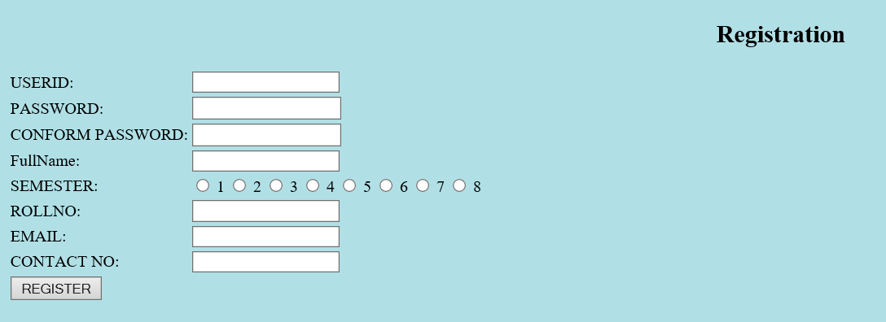

**1.1 Registration Page**

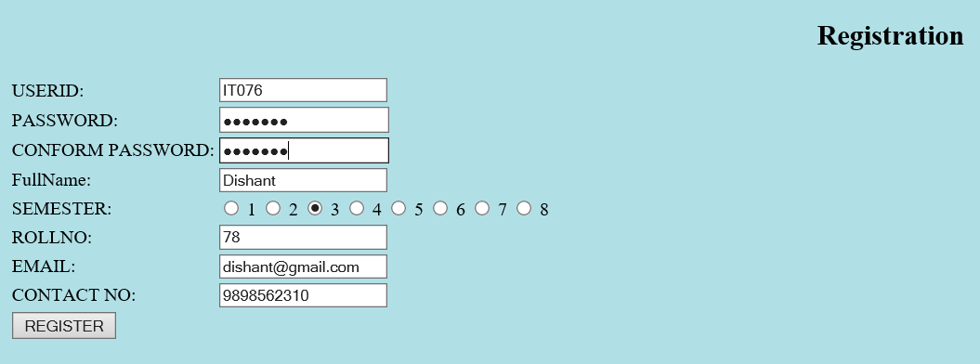

**1.2 Inserting Data**

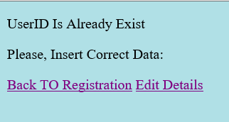



**1.3 data get inserted**

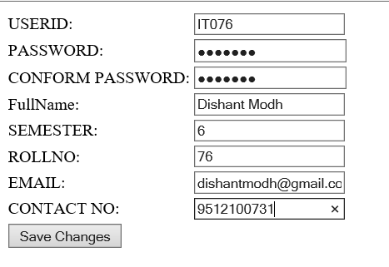

**1.4 After Clicking on Edit details**



**1.5 data gets updated in database**